EXECUTIVE SESSION AGENDA
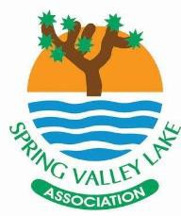
BOARD OF DIRECTORS
SPECIAL MEETING
JULY 7, 2021 & JULY 14, 2021
6:00 PM
COMMUNITY CENTER
12975 ROLLING RIDGE DRIVE PARKVIEW ROOM ~ CB4

As provided for in Civil Code §1363.05(b), notice is hereby given that an Executive Session will be conducted on 7/07/2021 and 7/14/2021. Executive session is a closed meeting.
BOARD MEMBERS | Brian Bickhart, President  Brian Hurst, Vice President  Lewis Ponce, Secretary  Cheri Boyd, Treasurer  JoAnne Romero, Director  Bill Scott, Director  Brad Letner, Director
STAFF | Alfred Logan, General Manager  Jeaneen Beam, Director of Admin & HR

- Call to Order
Roll Call

- Legal

- Contracts

- Adjourn

