Directions to Spring Valley Lake Community Parks
Play Fair Park in Apple Valley, CA –
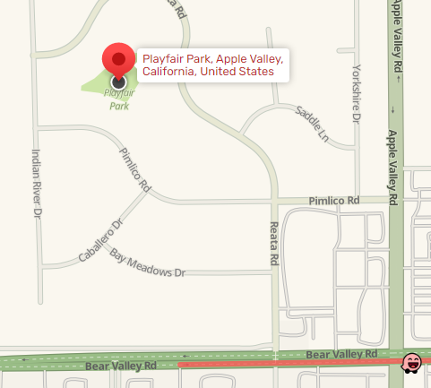
Play Fair Park has no physical address.
From Bear Valley Rd, turn left onto Reata.
Then turn left onto Pimlico.
The park is 0.2 miles on
the right side.

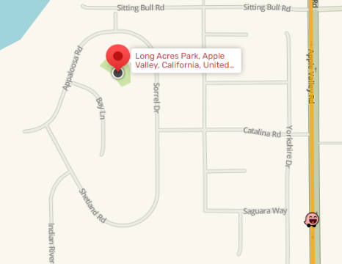
Long Acres Park in Apple Valley, CA –

Long Acres Park has no physical address.
From Apple Valley Rd, turn onto Catalina Rd.
Turn right onto Sorrel Dr. Then left onto Bay Lane.
The park is approx. 300 ft on the left side.

Meadowlark Park in Spring Valley Lake, CA –
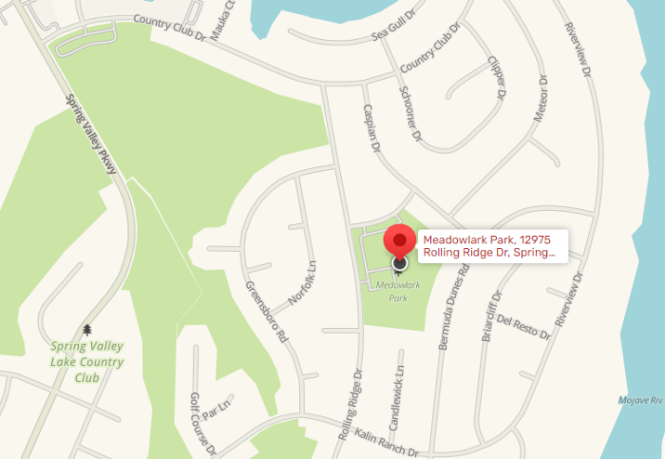
12975 Rolling Ridge Dr
Spring Valley Lake, CA 92395
From Country Club Dr. Turn onto
Rolling Ridge Dr. The park is on the left-hand side.

